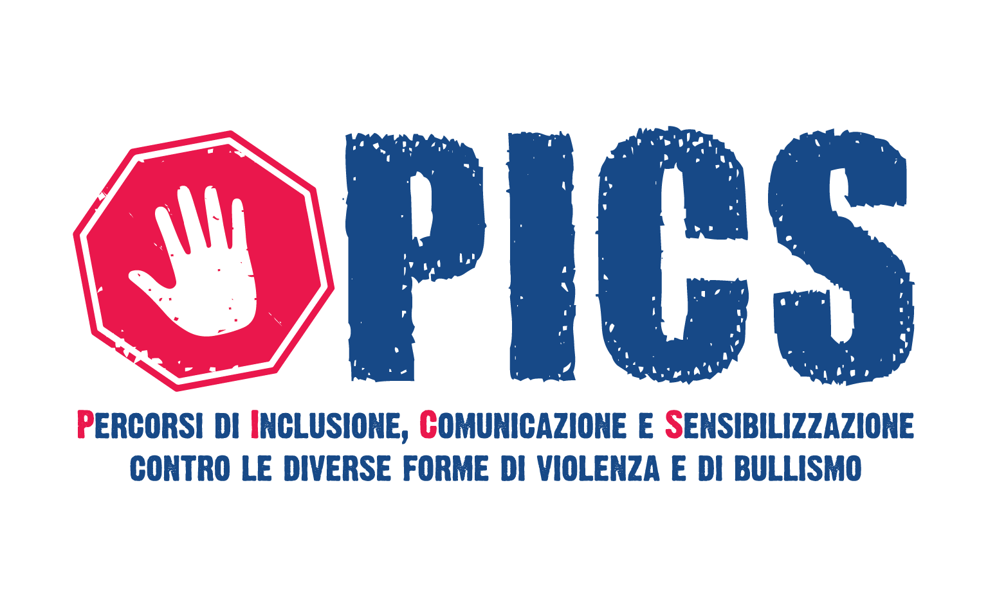

**NATIONAL MEETING**

**ONLINE**

**6TH JUNE 2021**

**INTRODUCTION**

On June 6, 2021, the national meeting of the PICS project, funded by the Ministry of Labor and Social Policy under Law 117 of 2017, was held. 60 young people participated, among those who had already taken part in the activities carried out at the regional level.

In the project, the following regions and provinces were involved: Valle d'Aosta, Aosta; Piemonte, Torino; Lombardia, Milano; Trentino Alto Adige, Trento; Veneto, Verona; Friuli Venezia Giulia, Udine e Trieste; Liguria, Genova; Toscana, Arezzo; Emilia Romagna, Bologna; Marche, Macerata; Umbria, Perugia e Terni; Lazio, Roma, Viterbo e Latina; Abruzzo, L'Aquila; Molise, Isernia; Campania, Napoli, Salerno; Puglia, Andria (BAT), Foggia e Taranto; Basilicata, Potenza; Calabria, Reggio Calabria e Vibo Valentia; Sicilia, Catania; Sardegna, Sassari.

The different geographical origin of the participants is emphasized because it is intended to highlight that the 60 young people did not come from the same reality and community, but from different areas of the country, each therefore with their own specific peculiarities. The discussion, therefore, was animated by very different points of view, linked to cultural traditions, social and economic contexts that are often very far from each other. This diversity represented an enrichment, giving a valuable contribution to the activities.

The EU Youth Dialogue is a tool designed by the European Union that aims to promote and facilitate the involvement of young people the decision-making process at the European level.

The public debate on youg people tends to focus on their little participation, without considering that this absence is largely due to the fact that we still consider some classical forms of participation that today have been almost disappeared.

The European Commission has dedicated to the issue a document containing guidelines regarding the inclusion of young people in the participatory process, through new channels and forms, in order to open up decision-making processes to young people, enabling them to constitute themselves as active and aware citizens. In this document we read, for example, that most young people demonstrate a clear desire to participate and influence society's choices - but according to more individual and more specific forms of engagement outside the old structures and mechanisms of participation. Thus, an essential element in order to implement the effective participation of young people is to know their values, perceptions and planning.

The PICS national meeting was originally designed to be held in-person. Unfortunately, due to the pandemic and the containment measures of the Italian government, it was necessary to switch it to an online mode. However, the participation of the young people was ensured thanks to the work of the facilitation team and led to a successful outcome of the activity, although it must be pointed out that much was lost compared to the in-presence experience

In peer-to-peer forms of sharing, the socialization, the development of attitudes of empathy, and physical contact are fundamental tools for the transfer of skills and knowledge, for mutual contamination on ideas, principles values, and for the creation of solidarity bonds.

**WORKSHOPS**

The **meeting** was based on different activities tha involved a various number of working groups.

**Workshop 1**

Activities of ice-breaking and team building.

In-depth analysis of the participiation and its forms.

In-depth analysis on key-concept as diversity, respect, rights, in everyday life.

**Workshop 2**

Analysis of the idea of violence, in a physical, psychological and verbal term.

In-depth analysis of personal experiences based on school-bullying.

It is fundamental to be aware of the phenomenon of bullying, to avoid bad habits among young people.

**Workshop 3**

Youth participation is the main theme of this workshop. It is important to underline that the participation refers to a wide-range of actions among the social and democratic life of our conuntry. Participating means voting, but also being part of a voluntary association, being part of a social movement and so on.

Analyis of new ways of youth participation, for instance through the social networks.

**Workshop 4**

“Reflection group” activity. Participants evaluation of PICS Project, especially in terms of their personal learning process.

**RESULTS**

We achieved valuable results in terms of learning process during the PICS Project.

The young participants became more aware of different forms of violence and are now more able to recognize it. They gained more confidence in being able to express their individuality and demand respect for who they are, and, at the same time, they understood the importance of committing to respect others equally. They had the opportunity to express their opinions, to develop their communication skills and to exchange ideas with their peers.

*Developed or improved skills*

* Active listening and communication: being able to listen to different points of view, express opinions and evaluate them together.
* Critical thinking: distinguishing between fact and opinion, being aware of biases and preconceptions, recognizing forms of manipulation.
* Working in group.
* Building consensus and dealing with conflict in a positive way.
* Expressing one's opinions while having self-confidence.
* Problem solving.
* Improving one's ability to ask for help.

*Developed or improved attitudes*

* Respect for oneself and others
* Increased self-esteem
* Confidence in being oneself and expressing one's.
* Empathy toward others and confidence in fighting inequality and discrimination.
* Sense of responsibility: the desire to contribute to a school or community improvement and the knowledge that young people have the power to create their own environment and future.

*Developed or improved knowledge*

* Awareness of violence in its different forms, its causes and consequences. Understanding strategies for combating violence and helping to protect youth and their peers.
* Understanding the importance of participation and active citizenship.

**EVALUATION**

A short questionnaire was administered at the end of the activities to assess the enjoyment and satisfaction of the young participants in the activities.

*General Evaluation*

*Content interest*

*Quality of information received and quality of the work of the trainers*

*Organization of working groups*

*Time management*

*Have you already participated to a similar project?*

*Would you like to be involved in similar events?*

*Do you prefer online or offline activities?*